TryHackMe – Snort
Week 3 SOC Analyst Internship | Room 4 Writeup
Room URL: https://tryhackme.com/room/snort
Note: This writeup follows the TryHackMe room content. Fill in machine-specific answers and attach your own screenshots after completing the exercises.

1. Objective
Learn IDS/IPS fundamentals, understand Snort, use its operating modes, inspect live and recorded traffic, and create rules to detect suspicious network activity.

2. Introduction to Snort
Snort is an open-source, rule-based Network Intrusion Detection and Prevention System (NIDS/NIPS). It analyses packets and compares them with rules to identify activity that may be malicious.
- Live traffic analysis and protocol analysis.
- Attack and probe detection.
- Packet logging and real-time alerting.
- Support for modules, plugins, and preprocessors.
- Cross-platform support, including Linux and Windows.

3. IDS vs IPS
Type | Purpose | Action
HIDS | Monitors one endpoint/host. | Detects and alerts.
NIDS | Monitors traffic across a network/subnet. | Detects and alerts.
HIPS | Protects one endpoint/host. | Prevents or blocks.
NIPS | Protects network traffic. | Prevents or blocks.
NBA | Learns normal network behaviour through baselining. | Detects anomalies and can trigger prevention.
TryHackMe Task 3 theory answers:
- HIPS – stops threats on a local machine.
- NIDS – detects threats on a local network.
- HIDS – detects threats on a local machine.
- NIPS – stops threats on a local network.
- Network Behaviour Analysis (NBA) detects anomalies.
- Snort is a rule-based NIPS.
- The NBA training period is called baselining.

4. Snort Modes
- Sniffer mode: Displays packets in the console, similar to tcpdump.
- Packet logger mode: Saves captured packets for later investigation.
- NIDS/NIPS mode: Applies rules to traffic and logs, alerts on, or drops matching packets.
- PCAP investigation: Reads previously captured packet files and applies configured rules.

5. First Interaction and Useful Commands
snort -V
Displays the installed Snort version/build.
sudo snort -c /etc/snort/snort.conf -T
Tests the configuration file for errors.
sudo snort -v -i eth0
Runs verbose sniffing on interface eth0.
sudo snort -v
Displays packet headers in verbose mode.
sudo snort -X
Displays full packet details in hexadecimal and text.
sudo snort -dev -l .
Captures and logs packet details to the current directory.
sudo snort -r capture.log
Reads a previously saved Snort packet log.
sudo snort -r capture.log icmp
Reads only ICMP packets from the log.
sudo snort -r capture.log tcp
Reads only TCP packets from the log.
sudo snort -r capture.log 'udp and port 53'
Uses a Berkeley Packet Filter to select UDP DNS traffic.
sudo snort -c /etc/snort/snort.conf -A console
Runs IDS mode and displays alerts on the console.
sudo snort -c /etc/snort/snort.conf -A full -l . -r sample.pcap
Analyses a PCAP using the selected configuration and full alert mode.

6. Snort Sniffer Parameters
- -v: Verbose packet output.
- -d: Displays packet payload data.
- -e: Displays link-layer header information.
- -X: Displays full packet details in hexadecimal and text.
- -i: Selects the network interface.

7. Packet Logger Parameters
- -l: Sets the logging/output directory.
- -K ASCII: Logs packets in ASCII format.
- -r: Reads previously captured packet logs.
- -n: Limits the number of packets processed.
- Files created with sudo may be owned by root. Use appropriate permissions or ownership to read them safely.

8. IDS/IPS Alert Modes
- -A console: Fast-style alerts shown on the console.
- -A cmg: Basic packet header details with payload in hex and text.
- -A full: Full alert information.
- -A fast: Short alert containing message, time, source/destination IPs and ports.
- -A none: Disables alert output.
Snort IPS mode can use the DAQ afpacket module and two interfaces, for example eth0:eth1. The TryHackMe exercise demonstrates the command: sudo snort -c /etc/snort/snort.conf -q -Q --daq afpacket -i eth0:eth1 -A console. Use only in the isolated lab environment.

9. Snort Rule Structure
A Snort rule contains a rule header and rule options. The header specifies action, protocol, source address/port, direction, and destination address/port. Options provide the message, identifiers, and detection conditions.
Example rule:
alert icmp any any <> any any (msg:"ICMP Packet Found"; sid:100001; rev:1;)
- alert: Generates an alert and logs the packet.
- log: Logs the packet.
- drop: Blocks and logs the packet.
- reject: Blocks, logs, and terminates the packet session.
- ->: Source-to-destination direction.
- <>: Bidirectional traffic.
- IP, TCP, UDP, ICMP: Protocol filters described for Snort 2.

10. Important Rule Options
Option | Purpose
msg | Message shown when the rule triggers.
sid | Unique Snort rule identifier.
rev | Rule revision number.
reference | External reference such as a CVE.
content | Matches data in the packet payload.
nocase | Makes content matching case-insensitive.
fast_pattern | Prioritises a content match to improve search performance.
id | Filters using the IP ID field.
flags | Filters using TCP flags such as SYN, ACK, FIN, RST, PSH, and URG.
dsize | Filters packets based on payload size.

11. Example Detection Rules
alert tcp any any <> any 80 (msg:"HTTP GET Request Found"; content:"GET"; sid:1000001; rev:1;)
alert tcp any any -> any any (msg:"SYN Packet Detected"; flags:S; sid:1000002; rev:1;)
alert icmp any any <> any any (msg:"ICMP Packet Found"; sid:1000003; rev:1;)
alert udp any any <> any 53 (msg:"DNS UDP Traffic"; sid:1000004; rev:1;)

12. PCAP Investigation
Snort can analyse saved PCAP files without capturing live traffic. The room uses commands such as:
sudo snort -c /etc/snort/snort.conf -A full -l . -r mx-1.pcap
sudo snort -c /etc/snort/snortv2.conf -A full -l . -r mx-1.pcap
sudo snort -c /etc/snort/snort.conf -A full -l . --pcap-list="mx-2.pcap mx-3.pcap"

13. Main Snort Components
- Packet Decoder: Collects packets and prepares them for preprocessing.
- Preprocessors: Arrange or modify packets for the detection engine.
- Detection Engine: Analyses packets by applying rules.
- Logging and Alerting: Generates logs and alerts.
- Outputs and Plugins: Support integrations and additional functionality.

14. Types of Snort Rules
- Community Rules: Free ruleset under GPLv2.
- Registered Rules: Free ruleset requiring registration, with a delay for subscriber rules.
- Subscriber Rules: Paid ruleset with more frequent updates.
The main configuration file is /etc/snort/snort.conf. User-created rules are commonly stored in local.rules. Back up configuration files before editing, test new rules, and comment out rules rather than deleting working rules.

15. Screenshot
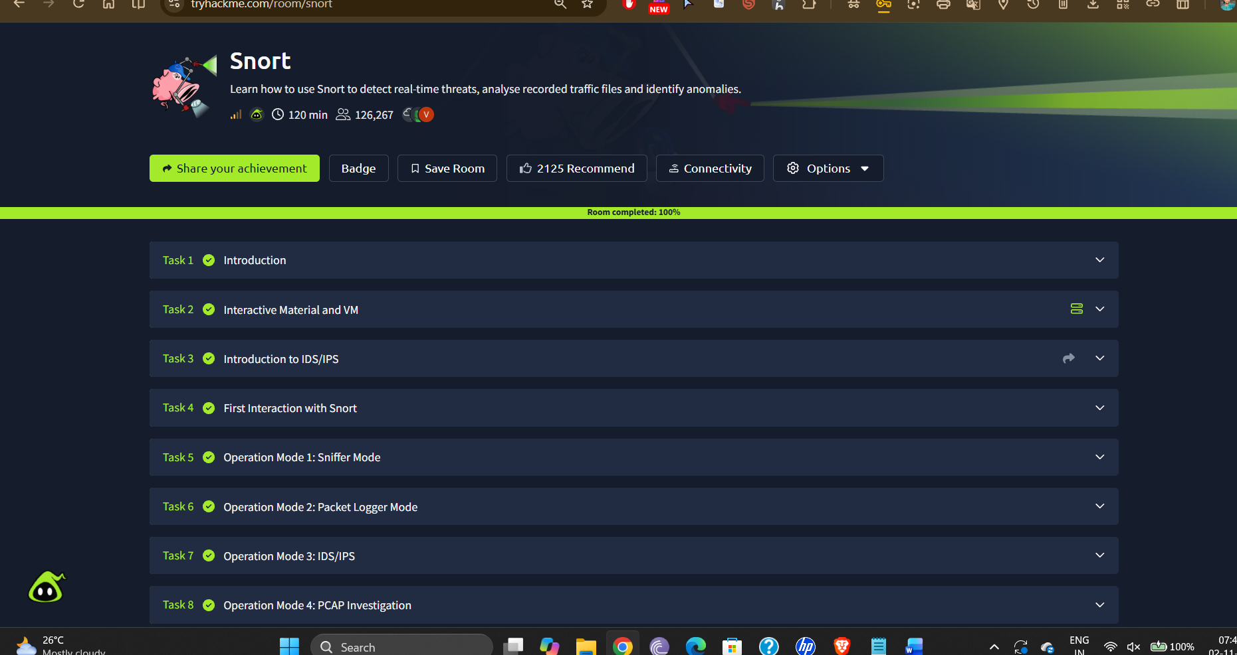

16 Conclusion
This room introduces Snort as a rule-based network intrusion detection and prevention tool. It covers IDS/IPS concepts, Snort modes, packet logging, PCAP analysis, rule syntax, detection options, and the main components of Snort. Complete the VM exercises and add the actual outputs and screenshots before submitting the writeup.
Reference: TryHackMe – Snort room content, accessed 2 November 2026.

